|  |  |  |
| --- | --- | --- |
| **Model Summary** | | |
| Specifications | Growing Method | CRT |
| Dependent Variable | quality |
| Independent Variables | fixedacidity, volatileacidity, citricacid, residualsugar, chlorides, freesulfurdioxide, totalsulfurdioxide, density, pH, sulphates, alcohol |
| Validation | None |
| Maximum Tree Depth | 20 |
| Minimum Cases in Parent Node | 5 |
| Minimum Cases in Child Node | 2 |
| Results | Independent Variables Included | alcohol, density, chlorides, volatileacidity, citricacid, sulphates, totalsulfurdioxide, fixedacidity, pH, residualsugar, freesulfurdioxide |
| Number of Nodes | 391 |
| Number of Terminal Nodes | 196 |
| Depth | 15 |

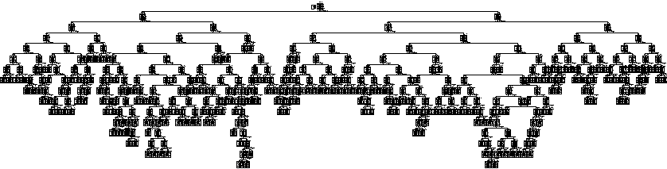

|  |  |
| --- | --- |
| **Risk** | |
| Estimate | Std. Error |
| .116 | .008 |
| Growing Method: CRT  Dependent Variable: quality | |

|  |  |  |  |  |  |  |  |
| --- | --- | --- | --- | --- | --- | --- | --- |
| **Classification** | | | | | | | |
| Observed | Predicted | | | | | | |
| 3 | 4 | 5 | 6 | 7 | 8 | Percent Correct |
| 3 | 2 | 0 | 5 | 2 | 1 | 0 | 20.0% |
| 4 | 0 | 22 | 17 | 14 | 0 | 0 | 41.5% |
| 5 | 0 | 2 | 640 | 34 | 5 | 0 | 94.0% |
| 6 | 0 | 1 | 51 | 570 | 14 | 2 | 89.3% |
| 7 | 0 | 0 | 7 | 23 | 168 | 1 | 84.4% |
| 8 | 0 | 0 | 0 | 3 | 3 | 12 | 66.7% |
| Overall Percentage | 0.1% | 1.6% | 45.0% | 40.4% | 11.9% | 0.9% | 88.4% |
| Growing Method: CRT  Dependent Variable: quality | | | | | | | |